Trouble on Gay Street
“Uh-huh we’re not talking about wages
We’re sitting right here ’til we get our land!”
– Vincent Lingiari, Gurindji
Gay Street is a story about violence that underpins a deceptive insistence for a home on other people’s land. The events described below took place on Yuggera country, land never ceded, onetime. – Ian Curr, Editor, 30 October 2025.
TESTIMONY
Okay. I was walking down Gay Street, Coopers Plains, and I saw an Australian flag flying outside the front of Heat Treatment Australia HTA, Brisbane. I took down the flag. It was crudely wired to an electricity pole near HTA’s entrance.
I felt the shock of being handcuffed from behind by a police officer. He had chased me down without me even seeing. I did not run, fearing injury in the gully nearby where a fit copper would have inevitably caught me. Truth is, my arrest so early in the demonstration, FFS! The flag was litter on the ground. There was no one to claim it. I know the government has made the Israeli flag sacrosanct in Australia, touch it and you labelled an anti-semite. But really, the Australian flag? Why is a cop so precious about a relic of British colonialism? It is only one of many.
Sergeant David TATTS then claimed that I had wilfully damaged the Australian flag. It was lying on the ground. There was no damage to it. TATTS then asked Ian for the flag as he had picked it up from his trike. I have to admit Ian was pretty nimble on that trike. He appeared on the scene before TATTS could clasp the metal handcuffs on me. TATTS asked Ian to give him the flag.
Ian refused point blank: “Well, you’ve got no right to ask me for anything yet because you’ve just arrested this person without saying what they have done wrong. “
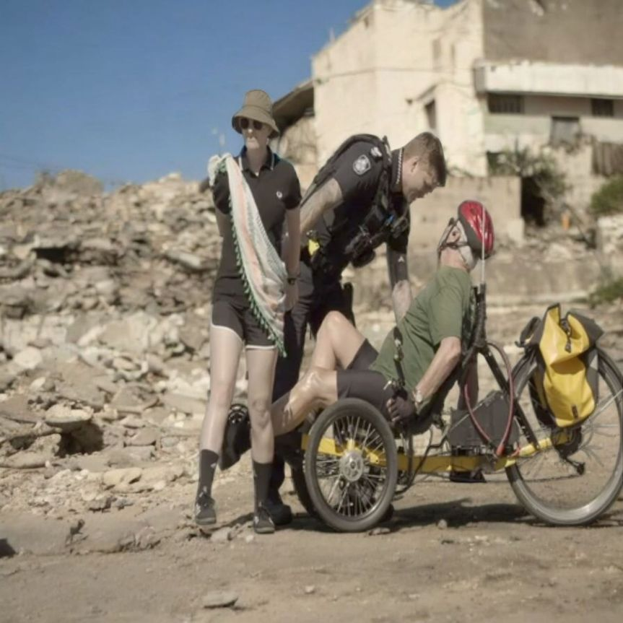
Affixing a flag to a power pole is a safety risk to sparkys doing maintenance work. I told TATTS the flag is made out of polyester and is a fire hazard, especially hanging like that, from an electricity pole.
Officer TATTS grabbed the flag by placing his foot on the flag, roughly tugging me by the handcuffs up against Ian’s bike and wrestling with him for the flag wired to Energex pole 44012 the night before by self-styled Australia’s Sons. It was as if TATTS was retrieving the Aussie flag from the rubble of Gaza. I was slightly off balance with the Saorise keffiyeh draped over my shoulder. Maybe TATTS is a Shankill Road boy? He was behaving like the Ulster constabulary. TATTS wouldn’t know my keffiyeh is the embodiment of the Irish and Palestinian struggle woven together.

TATTS took me across the road and put me into a police car, imprisoned in the rear passenger seat with my arms handcuffed behind my back. I was chuckling at the absurdity of my situation, but on the inside, I was angry at police complicity in protecting an arms factory. HTA had moved from hardening motor mower blades to heat treating F-35 parts with heaps of government subsidies.
To my surprise Ian then opened the car door where I was detained. Police immediately asked him: “What are you doing?”
Jim Dowling, behind the car, explained simply: “We’re trying to stop mass murder.”
David TATTS got out of the front passenger seat to tell Ian: ‘You’ll get into trouble if you open the police car door again.’ Ian told both TATTS and another cop, McGUINESS (not his name), that the arrest was unlawful because “we were part of an authorized assembly.”
A picket police liaison person then asked: “What’s the charge?” and TATTS replied “I don’t have to tell you that.” Police liaison replied: “but you have to tell them,” indicating me seated in the back seat of the police car. Other picketers began yelling: “You are overreacting!” McGUINESS backed up his mate saying, “She’s arrested for wilful damage” as he came around the back of the car towards Ian who responded “Get a grip, that’s not wilful damage!”
At a later stage, Ian asked another cop, Sgt McGUINESS, “Where are you taking them?” meaning both me and their other prisoner, Dave. McGUINESS had arrested Dave while TATTS detained me. McGUINESS wouldn’t tell Ian where they were taking us.
TATTS said to Ian, “I’ve got nothing to do with you. I’m just dealing with this matter.” I had become a ‘matter‘. Police put Dave and me into a police van. I overheard them talking to each other about going to Acacia Ridge Police Station. They wouldn’t say what was happening, TATTS spoke with Sergeant Tim McGUINESS and another police officer with serial number 444134 who drove us away in the police van.
From little things big things grow.
END OF TESTIMONY.
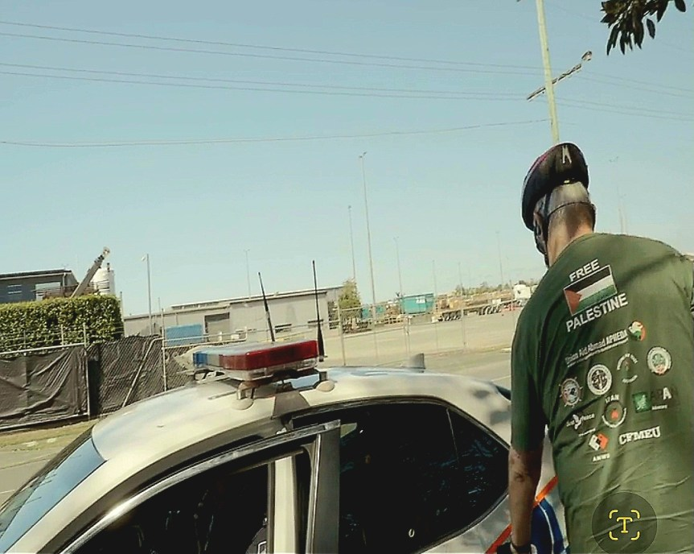
Later, Sergeant TATTS took a facial recognition shot of every person in a crowd of about 40 people at the picket. To make things worse, Snr Constable GUNG HO unstrapped his glock pistol when Ian opened the police car door. Coward. Picketers told police that they had overreacted in arresting the two people protesting the genocide in Gaza. It may have been worse if these cops were moonlighting in the IDF. How low would they stoop, given that they were protecting a weapons factory in Coopers Plains heating F-35 parts that are used directly by Israel in the genocide? Police can’t claim ignorance when they have been streaming the genocide on their phones for the last two years. You’d think one of them would object to being used?
Whatever our deficiencies in tactics, our numbers were strong. We had both police and HTA on the defensive. All up, a couple of dodgy arrests and some fines for defective vehicles were not a bad result.
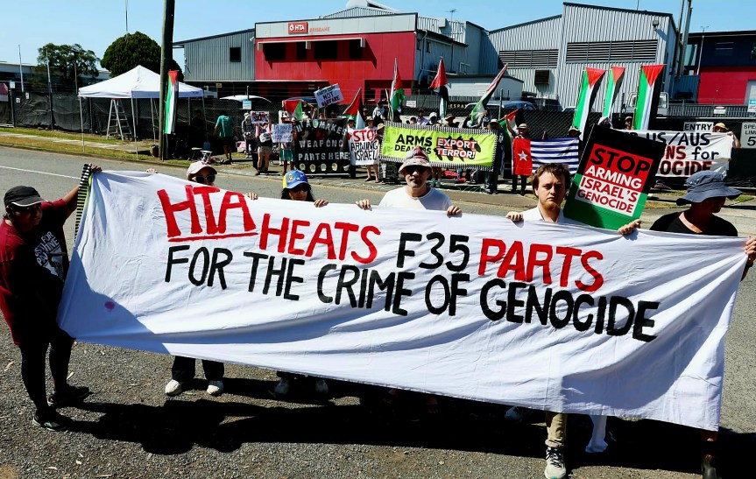Picket in Gay Street outside HTA in Coopers Plains, Brisbane, Magandjin on 21 October 2025. Photo Alex Bainbridge, Green Left Weekly.
You often hear people say that if they were in Nazi Germany in the 1930s, they would have opposed the Holocaust. But would they? Just look at history. The principle of Never Again arose from the ashes of the Holocaust yet here we have Israelis backing it to the hilt again while Albo wears his Joy Division t-shirts. Surely he must know who Joy Division were?
If Labor controlled unions won’t do the tough grind at the shop floor convincing our members that weapons factories are not the way to go, who is? Labor and Liberal politicians are still yelling from the rooftops of weapons factories “Jobs Jobs Jobs!” No one can claim lack of knowledge. The evidence is live streamed. Boeing, Elbit systems, Ferra engineering, Lockheed Martin, HTA and Rheinmetall are complicit in mass murder.
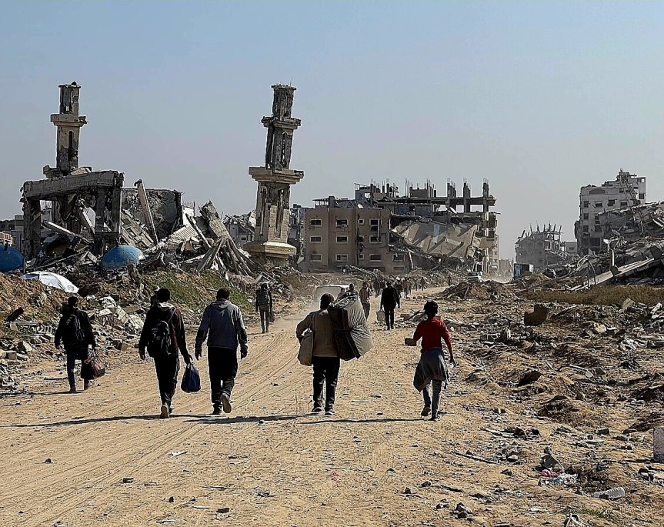95% of Gaza obliterated by Israel bombed by US supplied Lockheed Martin F35s
Ian Curr
1 November 2025


